**Edge Computing Laboratory**

**Lab Assignment 9**

**Name:** Gaurav Gadekar

**Class:** TY AIEC Batch C

**Enrollment No:** MITU23BTCSD120

**Roll No:** D2233120

### **Title: The Object Detection using Camera on Edge Computing Devices**

### **Objective:** Build a project to detect an object using Edge Computing **Tasks:**

* Generate the dataset for customized object
* Configure Edge Impulse for Object Detection
* Building and Training a Model
* Deploy on Edge Computing Device

### **Introduction**

Edge Impulse is a development platform for machine learning on edge devices, targeted at developers who want to create intelligent device solutions. The " Camera "sensor reading equivalent in Edge Impulse would typically involve creating a simple machine learning model that can run on an edge device, like classifying sensor data or recognizing a basic pattern.

**Materials Required**

• Nano BLE Sense Board

### Theory

GPIO (General Purpose Input/Output) pins on the Raspberry Pi are used for interfacing with other electronic components. BCM numbering refers to the pin numbers in the Broadcom SOC channel, which is a more consistent way to refer to the GPIO pins across different versions of the

Here’s a high-level overview of steps you'd follow to create a "Hello World" project on Edge Impulse:

**Steps to Configure the Edge Impulse:**

1. Create an Account and New Project:
   * Sign up for an Edge Impulse account.
   * Create a new project from the dashboard.
2. Connect a Device:
   * You can use a supported development board or your smartphone as a sensor device.
   * Follow the instructions to connect your device to your Edge Impulse project.
3. Collect Data:
   * Use the Edge Impulse mobile app or the Web interface to collect data from the onboard sensors.
   * For a "Hello World" project, you could collect accelerometer data, for instance.
4. Create an Impulse:

Go to the 'Create impulse' page.

* + Add a processing block (e.g., time-series data) and a learning block (e.g., classification).
  + Save the impulse, which defines the machine learning pipeline.

1. Design a Neural Network:
   * Navigate to the 'NN Classifier' under the 'Learning blocks'.
   * Design a simple neural network. Edge Impulse provides a default architecture that works well for most basic tasks.
2. Train the Model:
   * Click on the 'Start training' button to train your machine learning model with the collected data.
3. Test the Model:
   * Once the model is trained, you can test its performance with new data in the 'Model Testing' tab.
4. Deploy the Model:
   * Go to the 'Deployment' tab.
   * Select the deployment method that suits your edge device (e.g., Arduino library, WebAssembly, container, etc.).
   * Follow the instructions to deploy the model to your device.
5. Run Inference:
   * With the model deployed, run inference on the edge device to see it classifying data in real-time.
6. Monitor:
   * You can monitor the performance of your device through the Edge Impulse studio.

**Paste your Edge Impulse project’s Results:**

1. **Dataset Image**

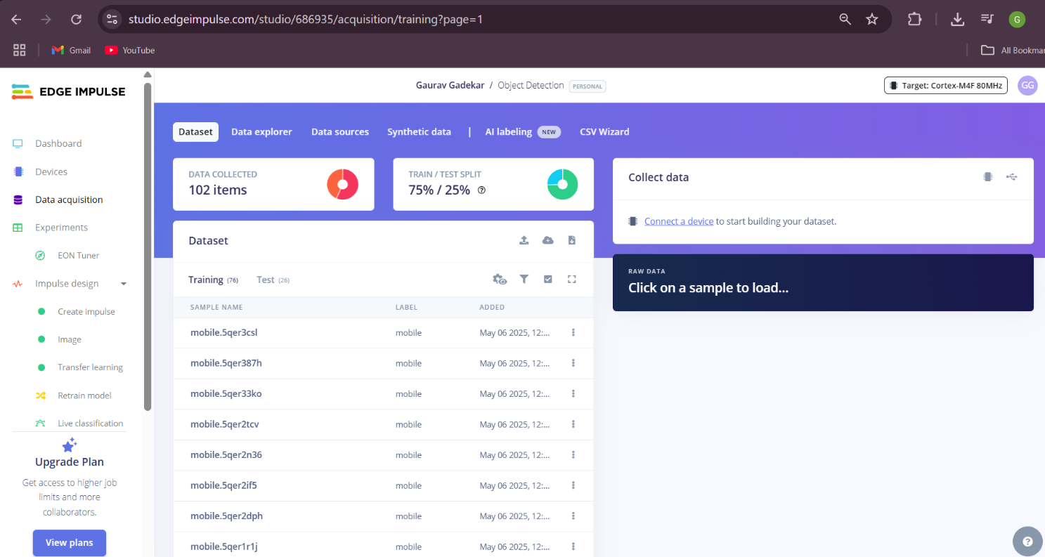

1. **Feature extraction - Image**

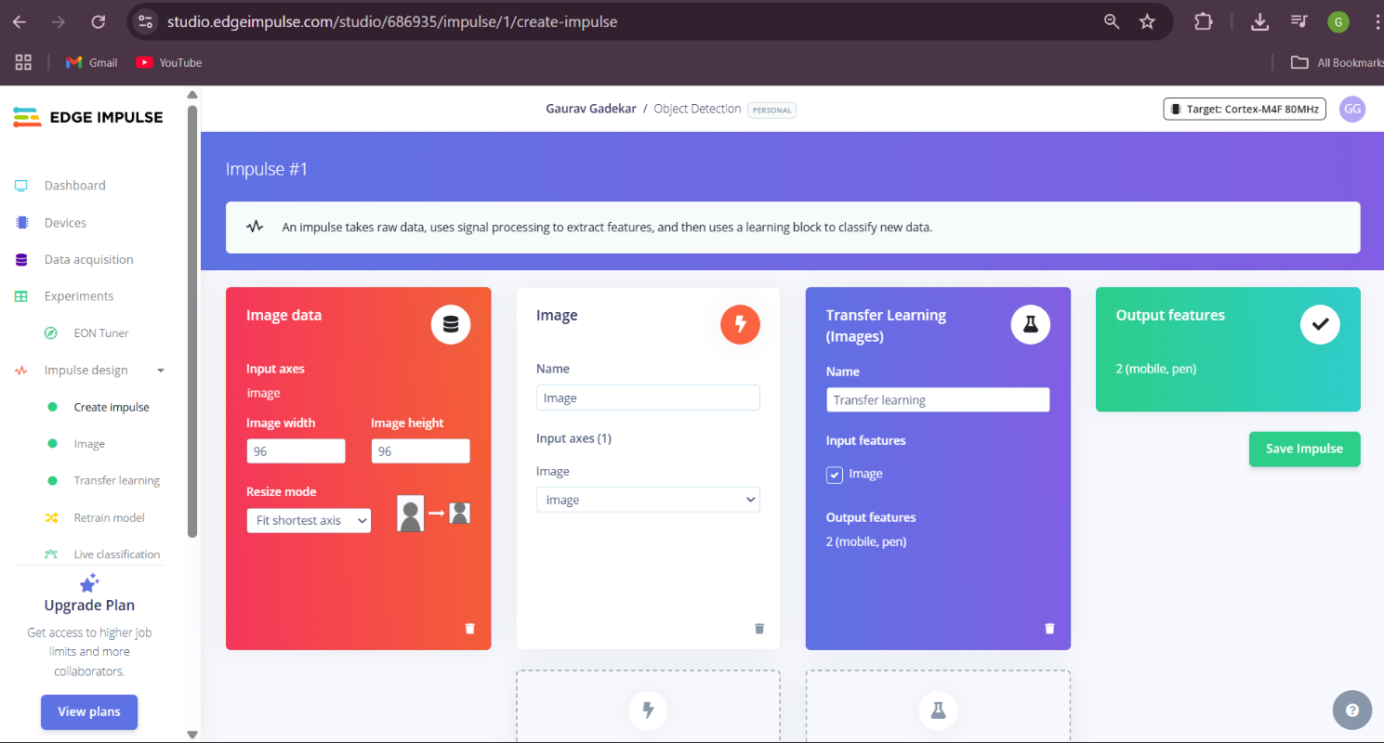

1. **Accuracy / Loss - Confusion Matrix – image**

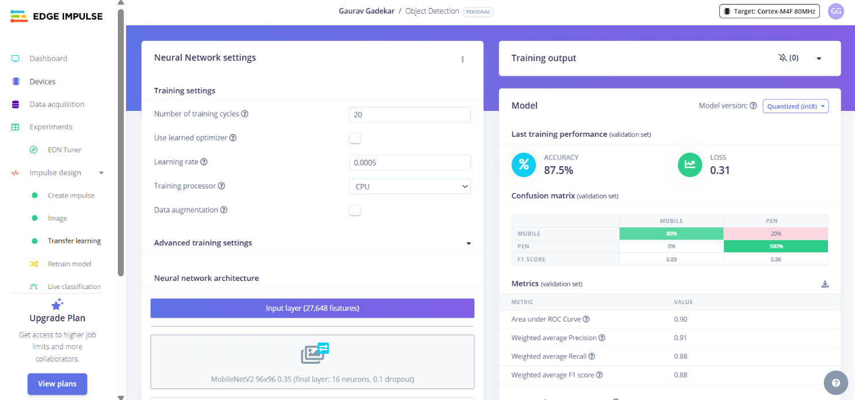

1. **Validation Result – Image**

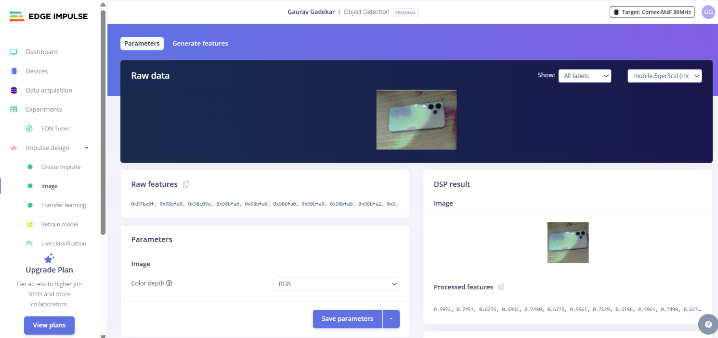

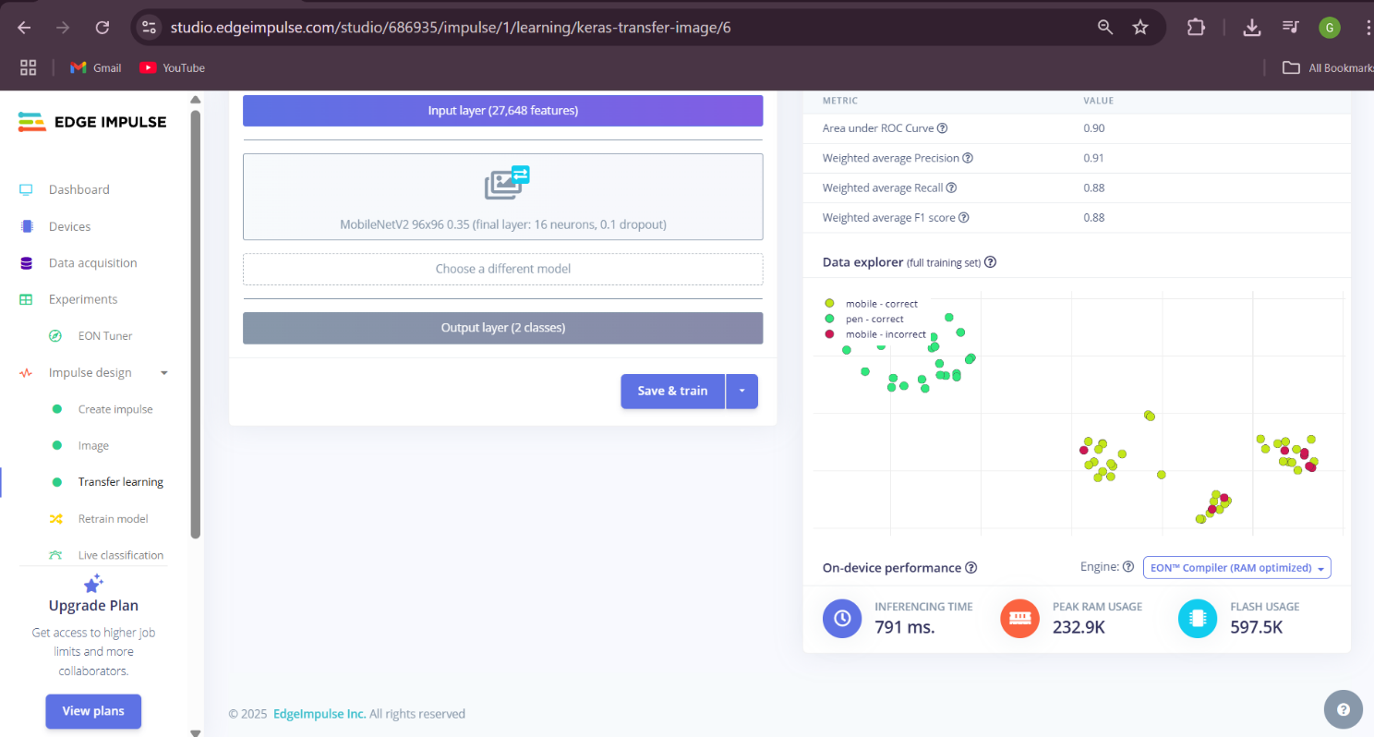

1. **Copy the code of Arduino Sketch**

/* Edge Impulse ingestion SDK

* Copyright (c) 2022 EdgeImpulse Inc.

*

* Licensed under the Apache License, Version 2.0 (the "License");

* you may not use this file except in compliance with the License.

* You may obtain a copy of the License at

* http://www.apache.org/licenses/LICENSE-2.0

*

* Unless required by applicable law or agreed to in writing, software

* distributed under the License is distributed on an "AS IS" BASIS,

* WITHOUT WARRANTIES OR CONDITIONS OF ANY KIND, either express or implied.

* See the License for the specific language governing permissions and

* limitations under the License.

*

*/

/* Includes ---------------------------------------------------------------- */

#include <Object_Detection_inferencing.h>

#include <Arduino_OV767X.h> //Click here to get the library: https://www.arduino.cc/reference/en/libraries/arduino_ov767x/

#include <stdint.h>

#include <stdlib.h>

/* Constant variables ------------------------------------------------------- */

#define EI_CAMERA_RAW_FRAME_BUFFER_COLS 160

#define EI_CAMERA_RAW_FRAME_BUFFER_ROWS 120

#define DWORD_ALIGN_PTR(a) ((a & 0x3) ?(((uintptr_t)a + 0x4) & ~(uintptr_t)0x3) : a)

/*

** NOTE: If you run into TFLite arena allocation issue.

**

** This may be due to may dynamic memory fragmentation.

** Try defining "-DEI_CLASSIFIER_ALLOCATION_STATIC" in boards.local.txt (create

** if it doesn't exist) and copy this file to

** `<ARDUINO_CORE_INSTALL_PATH>/arduino/hardware/<mbed_core>/<core_version>/`.

**

** See

** (https://support.arduino.cc/hc/en-us/articles/360012076960-Where-are-the-installed-cores-located-)

** to find where Arduino installs cores on your machine.

**

** If the problem persists then there's not enough memory for this model and application.

*/

/* Edge Impulse ------------------------------------------------------------- */

class OV7675 : public OV767X {

public:

int begin(int resolution, int format, int fps);

void readFrame(void* buffer);

private:

int vsyncPin;

int hrefPin;

int pclkPin;

int xclkPin;

volatile uint32_t* vsyncPort;

uint32_t vsyncMask;

volatile uint32_t* hrefPort;

uint32_t hrefMask;

volatile uint32_t* pclkPort;

uint32_t pclkMask;

uint16_t width;

uint16_t height;

uint8_t bytes_per_pixel;

uint16_t bytes_per_row;

uint8_t buf_rows;

uint16_t buf_size;

uint8_t resize_height;

uint8_t *raw_buf;

void *buf_mem;

uint8_t *intrp_buf;

uint8_t *buf_limit;

void readBuf();

int allocate_scratch_buffs();

int deallocate_scratch_buffs();

};

typedef struct {

size_t width;

size_t height;

} ei_device_resize_resolutions_t;

/**

* @brief Check if new serial data is available

*

* @return Returns number of available bytes

*/

int ei_get_serial_available(void) {

return Serial.available();

}

/**

* @brief Get next available byte

*

* @return byte

*/

char ei_get_serial_byte(void) {

return Serial.read();

}

/* Private variables ------------------------------------------------------- */

static OV7675 Cam;

static bool is_initialised = false;

/*

** @brief points to the output of the capture

*/

static uint8_t *ei_camera_capture_out = NULL;

uint32_t resize_col_sz;

uint32_t resize_row_sz;

bool do_resize = false;

bool do_crop = false;

static bool debug_nn = false; // Set this to true to see e.g. features generated from the raw signal

/* Function definitions ------------------------------------------------------- */

bool ei_camera_init(void);

void ei_camera_deinit(void);

bool ei_camera_capture(uint32_t img_width, uint32_t img_height, uint8_t *out_buf) ;

int calculate_resize_dimensions(uint32_t out_width, uint32_t out_height, uint32_t *resize_col_sz, uint32_t *resize_row_sz, bool *do_resize);

void resizeImage(int srcWidth, int srcHeight, uint8_t *srcImage, int dstWidth, int dstHeight, uint8_t *dstImage, int iBpp);

void cropImage(int srcWidth, int srcHeight, uint8_t *srcImage, int startX, int startY, int dstWidth, int dstHeight, uint8_t *dstImage, int iBpp);

/**

* @brief Arduino setup function

*/

void setup()

{

// put your setup code here, to run once:

Serial.begin(115200);

// comment out the below line to cancel the wait for USB connection (needed for native USB)

while (!Serial);

Serial.println("Edge Impulse Inferencing Demo");

// summary of inferencing settings (from model_metadata.h)

ei_printf("Inferencing settings:\n");

ei_printf("\tImage resolution: %dx%d\n", EI_CLASSIFIER_INPUT_WIDTH, EI_CLASSIFIER_INPUT_HEIGHT);

ei_printf("\tFrame size: %d\n", EI_CLASSIFIER_DSP_INPUT_FRAME_SIZE);

ei_printf("\tNo. of classes: %d\n", sizeof(ei_classifier_inferencing_categories) / sizeof(ei_classifier_inferencing_categories[0]));

}

/**

* @brief Get data and run inferencing

*

* @param[in] debug Get debug info if true

*/

void loop()

{

bool stop_inferencing = false;

while(stop_inferencing == false) {

ei_printf("\nStarting inferencing in 2 seconds...\n");

// instead of wait_ms, we'll wait on the signal, this allows threads to cancel us...

if (ei_sleep(2000) != EI_IMPULSE_OK) {

break;

}

ei_printf("Taking photo...\n");

if (ei_camera_init() == false) {

ei_printf("ERR: Failed to initialize image sensor\r\n");

break;

}

// choose resize dimensions

uint32_t resize_col_sz;

uint32_t resize_row_sz;

bool do_resize = false;

int res = calculate_resize_dimensions(EI_CLASSIFIER_INPUT_WIDTH, EI_CLASSIFIER_INPUT_HEIGHT, &resize_col_sz, &resize_row_sz, &do_resize);

if (res) {

ei_printf("ERR: Failed to calculate resize dimensions (%d)\r\n", res);

break;

}

void *snapshot_mem = NULL;

uint8_t *snapshot_buf = NULL;

snapshot_mem = ei_malloc(resize_col_sz*resize_row_sz*2);

if(snapshot_mem == NULL) {

ei_printf("failed to create snapshot_mem\r\n");

break;

}

snapshot_buf = (uint8_t *)DWORD_ALIGN_PTR((uintptr_t)snapshot_mem);

if (ei_camera_capture(EI_CLASSIFIER_INPUT_WIDTH, EI_CLASSIFIER_INPUT_HEIGHT, snapshot_buf) == false) {

ei_printf("Failed to capture image\r\n");

if (snapshot_mem) ei_free(snapshot_mem);

break;

}

ei::signal_t signal;

signal.total_length = EI_CLASSIFIER_INPUT_WIDTH * EI_CLASSIFIER_INPUT_HEIGHT;

signal.get_data = &ei_camera_cutout_get_data;

// run the impulse: DSP, neural network and the Anomaly algorithm

ei_impulse_result_t result = { 0 };

EI_IMPULSE_ERROR ei_error = run_classifier(&signal, &result, debug_nn);

if (ei_error != EI_IMPULSE_OK) {

ei_printf("Failed to run impulse (%d)\n", ei_error);

ei_free(snapshot_mem);

break;

}

// print the predictions

ei_printf("Predictions (DSP: %d ms., Classification: %d ms., Anomaly: %d ms.): \n",

result.timing.dsp, result.timing.classification, result.timing.anomaly);

#if EI_CLASSIFIER_OBJECT_DETECTION == 1

ei_printf("Object detection bounding boxes:\r\n");

for (uint32_t i = 0; i < result.bounding_boxes_count; i++) {

ei_impulse_result_bounding_box_t bb = result.bounding_boxes[i];

if (bb.value == 0) {

continue;

}

ei_printf(" %s (%f) [ x: %u, y: %u, width: %u, height: %u ]\r\n",

bb.label,

bb.value,

bb.x,

bb.y,

bb.width,

bb.height);

}

// Print the prediction results (classification)

#else

ei_printf("Predictions:\r\n");

for (uint16_t i = 0; i < EI_CLASSIFIER_LABEL_COUNT; i++) {

ei_printf(" %s: ", ei_classifier_inferencing_categories[i]);

ei_printf("%.5f\r\n", result.classification[i].value);

}

#endif

// Print anomaly result (if it exists)

#if EI_CLASSIFIER_HAS_ANOMALY

ei_printf("Anomaly prediction: %.3f\r\n", result.anomaly);

#endif

#if EI_CLASSIFIER_HAS_VISUAL_ANOMALY

ei_printf("Visual anomalies:\r\n");

for (uint32_t i = 0; i < result.visual_ad_count; i++) {

ei_impulse_result_bounding_box_t bb = result.visual_ad_grid_cells[i];

if (bb.value == 0) {

continue;

}

ei_printf(" %s (%f) [ x: %u, y: %u, width: %u, height: %u ]\r\n",

bb.label,

bb.value,

bb.x,

bb.y,

bb.width,

bb.height);

}

#endif

while (ei_get_serial_available() > 0) {

if (ei_get_serial_byte() == 'b') {

ei_printf("Inferencing stopped by user\r\n");

stop_inferencing = true;

}

}

if (snapshot_mem) ei_free(snapshot_mem);

}

ei_camera_deinit();

}

/**

* @brief Determine whether to resize and to which dimension

*

* @param[in] out_width width of output image

* @param[in] out_height height of output image

* @param[out] resize_col_sz pointer to frame buffer's column/width value

* @param[out] resize_row_sz pointer to frame buffer's rows/height value

* @param[out] do_resize returns whether to resize (or not)

*

*/

int calculate_resize_dimensions(uint32_t out_width, uint32_t out_height, uint32_t *resize_col_sz, uint32_t *resize_row_sz, bool *do_resize)

{

size_t list_size = 2;

const ei_device_resize_resolutions_t list[list_size] = { {42,32}, {128,96} };

// (default) conditions

*resize_col_sz = EI_CAMERA_RAW_FRAME_BUFFER_COLS;

*resize_row_sz = EI_CAMERA_RAW_FRAME_BUFFER_ROWS;

*do_resize = false;

for (size_t ix = 0; ix < list_size; ix++) {

if ((out_width <= list[ix].width) && (out_height <= list[ix].height)) {

*resize_col_sz = list[ix].width;

*resize_row_sz = list[ix].height;

*do_resize = true;

break;

}

}

return 0;

}

/**

* @brief Setup image sensor & start streaming

*

* @retval false if initialisation failed

*/

bool ei_camera_init(void) {

if (is_initialised) return true;

if (!Cam.begin(QQVGA, RGB565, 1)) { // VGA downsampled to QQVGA (OV7675)

ei_printf("ERR: Failed to initialize camera\r\n");

return false;

}

is_initialised = true;

return true;

}

/**

* @brief Stop streaming of sensor data

*/

void ei_camera_deinit(void) {

if (is_initialised) {

Cam.end();

is_initialised = false;

}

}

/**

* @brief Capture, rescale and crop image

*

* @param[in] img_width width of output image

* @param[in] img_height height of output image

* @param[in] out_buf pointer to store output image, NULL may be used

* when full resolution is expected.

*

* @retval false if not initialised, image captured, rescaled or cropped failed

*

*/

bool ei_camera_capture(uint32_t img_width, uint32_t img_height, uint8_t *out_buf)

{

if (!is_initialised) {

ei_printf("ERR: Camera is not initialized\r\n");

return false;

}

if (!out_buf) {

ei_printf("ERR: invalid parameters\r\n");

return false;

}

// choose resize dimensions

int res = calculate_resize_dimensions(img_width, img_height, &resize_col_sz, &resize_row_sz, &do_resize);

if (res) {

ei_printf("ERR: Failed to calculate resize dimensions (%d)\r\n", res);

return false;

}

if ((img_width != resize_col_sz)

|| (img_height != resize_row_sz)) {

do_crop = true;

}

Cam.readFrame(out_buf); // captures image and resizes

if (do_crop) {

uint32_t crop_col_sz;

uint32_t crop_row_sz;

uint32_t crop_col_start;

uint32_t crop_row_start;

crop_row_start = (resize_row_sz - img_height) / 2;

crop_col_start = (resize_col_sz - img_width) / 2;

crop_col_sz = img_width;

crop_row_sz = img_height;

//ei_printf("crop cols: %d, rows: %d\r\n", crop_col_sz,crop_row_sz);

cropImage(resize_col_sz, resize_row_sz,

out_buf,

crop_col_start, crop_row_start,

crop_col_sz, crop_row_sz,

out_buf,

16);

}

// The following variables should always be assigned

// if this routine is to return true

// cutout values

//ei_camera_snapshot_is_resized = do_resize;

//ei_camera_snapshot_is_cropped = do_crop;

ei_camera_capture_out = out_buf;

return true;

}

/**

* @brief Convert RGB565 raw camera buffer to RGB888

*

* @param[in] offset pixel offset of raw buffer

* @param[in] length number of pixels to convert

* @param[out] out_buf pointer to store output image

*/

int ei_camera_cutout_get_data(size_t offset, size_t length, float *out_ptr) {

size_t pixel_ix = offset * 2;

size_t bytes_left = length;

size_t out_ptr_ix = 0;

// read byte for byte

while (bytes_left != 0) {

// grab the value and convert to r/g/b

uint16_t pixel = (ei_camera_capture_out[pixel_ix] << 8) | ei_camera_capture_out[pixel_ix+1];

uint8_t r, g, b;

r = ((pixel >> 11) & 0x1f) << 3;

g = ((pixel >> 5) & 0x3f) << 2;

b = (pixel & 0x1f) << 3;

// then convert to out_ptr format

float pixel_f = (r << 16) + (g << 8) + b;

out_ptr[out_ptr_ix] = pixel_f;

// and go to the next pixel

out_ptr_ix++;

pixel_ix+=2;

bytes_left--;

}

// and done!

return 0;

}

// This include file works in the Arduino environment

// to define the Cortex-M intrinsics

#ifdef __ARM_FEATURE_SIMD32

#include <device.h>

#endif

// This needs to be < 16 or it won't fit. Cortex-M4 only has SIMD for signed multiplies

#define FRAC_BITS 14

#define FRAC_VAL (1<<FRAC_BITS)

#define FRAC_MASK (FRAC_VAL - 1)

//

// Resize

//

// Assumes that the destination buffer is dword-aligned

// Can be used to resize the image smaller or larger

// If resizing much smaller than 1/3 size, then a more rubust algorithm should average all of the pixels

// This algorithm uses bilinear interpolation - averages a 2x2 region to generate each new pixel

//

// Optimized for 32-bit MCUs

// supports 8 and 16-bit pixels

void resizeImage(int srcWidth, int srcHeight, uint8_t *srcImage, int dstWidth, int dstHeight, uint8_t *dstImage, int iBpp)

{

uint32_t src_x_accum, src_y_accum; // accumulators and fractions for scaling the image

uint32_t x_frac, nx_frac, y_frac, ny_frac;

int x, y, ty, tx;

if (iBpp != 8 && iBpp != 16)

return;

src_y_accum = FRAC_VAL/2; // start at 1/2 pixel in to account for integer downsampling which might miss pixels

const uint32_t src_x_frac = (srcWidth * FRAC_VAL) / dstWidth;

const uint32_t src_y_frac = (srcHeight * FRAC_VAL) / dstHeight;

const uint32_t r_mask = 0xf800f800;

const uint32_t g_mask = 0x07e007e0;

const uint32_t b_mask = 0x001f001f;

uint8_t *s, *d;

uint16_t *s16, *d16;

uint32_t x_frac2, y_frac2; // for 16-bit SIMD

for (y=0; y < dstHeight; y++) {

ty = src_y_accum >> FRAC_BITS; // src y

y_frac = src_y_accum & FRAC_MASK;

src_y_accum += src_y_frac;

ny_frac = FRAC_VAL - y_frac; // y fraction and 1.0 - y fraction

y_frac2 = ny_frac | (y_frac << 16); // for M4/M4 SIMD

s = &srcImage[ty * srcWidth];

s16 = (uint16_t *)&srcImage[ty * srcWidth * 2];

d = &dstImage[y * dstWidth];

d16 = (uint16_t *)&dstImage[y * dstWidth * 2];

src_x_accum = FRAC_VAL/2; // start at 1/2 pixel in to account for integer downsampling which might miss pixels

if (iBpp == 8) {

for (x=0; x < dstWidth; x++) {

uint32_t tx, p00,p01,p10,p11;

tx = src_x_accum >> FRAC_BITS;

x_frac = src_x_accum & FRAC_MASK;

nx_frac = FRAC_VAL - x_frac; // x fraction and 1.0 - x fraction

x_frac2 = nx_frac | (x_frac << 16);

src_x_accum += src_x_frac;

p00 = s[tx]; p10 = s[tx+1];

p01 = s[tx+srcWidth]; p11 = s[tx+srcWidth+1];

#ifdef __ARM_FEATURE_SIMD32

p00 = __SMLAD(p00 | (p10<<16), x_frac2, FRAC_VAL/2) >> FRAC_BITS; // top line

p01 = __SMLAD(p01 | (p11<<16), x_frac2, FRAC_VAL/2) >> FRAC_BITS; // bottom line

p00 = __SMLAD(p00 | (p01<<16), y_frac2, FRAC_VAL/2) >> FRAC_BITS; // combine

#else // generic C code

p00 = ((p00 * nx_frac) + (p10 * x_frac) + FRAC_VAL/2) >> FRAC_BITS; // top line

p01 = ((p01 * nx_frac) + (p11 * x_frac) + FRAC_VAL/2) >> FRAC_BITS; // bottom line

p00 = ((p00 * ny_frac) + (p01 * y_frac) + FRAC_VAL/2) >> FRAC_BITS; // combine top + bottom

#endif // Cortex-M4/M7

*d++ = (uint8_t)p00; // store new pixel

} // for x

} // 8-bpp

else

{ // RGB565

for (x=0; x < dstWidth; x++) {

uint32_t tx, p00,p01,p10,p11;

uint32_t r00, r01, r10, r11, g00, g01, g10, g11, b00, b01, b10, b11;

tx = src_x_accum >> FRAC_BITS;

x_frac = src_x_accum & FRAC_MASK;

nx_frac = FRAC_VAL - x_frac; // x fraction and 1.0 - x fraction

x_frac2 = nx_frac | (x_frac << 16);

src_x_accum += src_x_frac;

p00 = __builtin_bswap16(s16[tx]); p10 = __builtin_bswap16(s16[tx+1]);

p01 = __builtin_bswap16(s16[tx+srcWidth]); p11 = __builtin_bswap16(s16[tx+srcWidth+1]);

#ifdef __ARM_FEATURE_SIMD32

{

p00 |= (p10 << 16);

p01 |= (p11 << 16);

r00 = (p00 & r_mask) >> 1; g00 = p00 & g_mask; b00 = p00 & b_mask;

r01 = (p01 & r_mask) >> 1; g01 = p01 & g_mask; b01 = p01 & b_mask;

r00 = __SMLAD(r00, x_frac2, FRAC_VAL/2) >> FRAC_BITS; // top line

r01 = __SMLAD(r01, x_frac2, FRAC_VAL/2) >> FRAC_BITS; // bottom line

r00 = __SMLAD(r00 | (r01<<16), y_frac2, FRAC_VAL/2) >> FRAC_BITS; // combine

g00 = __SMLAD(g00, x_frac2, FRAC_VAL/2) >> FRAC_BITS; // top line

g01 = __SMLAD(g01, x_frac2, FRAC_VAL/2) >> FRAC_BITS; // bottom line

g00 = __SMLAD(g00 | (g01<<16), y_frac2, FRAC_VAL/2) >> FRAC_BITS; // combine

b00 = __SMLAD(b00, x_frac2, FRAC_VAL/2) >> FRAC_BITS; // top line

b01 = __SMLAD(b01, x_frac2, FRAC_VAL/2) >> FRAC_BITS; // bottom line

b00 = __SMLAD(b00 | (b01<<16), y_frac2, FRAC_VAL/2) >> FRAC_BITS; // combine

}

#else // generic C code

{

r00 = (p00 & r_mask) >> 1; g00 = p00 & g_mask; b00 = p00 & b_mask;

r10 = (p10 & r_mask) >> 1; g10 = p10 & g_mask; b10 = p10 & b_mask;

r01 = (p01 & r_mask) >> 1; g01 = p01 & g_mask; b01 = p01 & b_mask;

r11 = (p11 & r_mask) >> 1; g11 = p11 & g_mask; b11 = p11 & b_mask;

r00 = ((r00 * nx_frac) + (r10 * x_frac) + FRAC_VAL/2) >> FRAC_BITS; // top line

r01 = ((r01 * nx_frac) + (r11 * x_frac) + FRAC_VAL/2) >> FRAC_BITS; // bottom line

r00 = ((r00 * ny_frac) + (r01 * y_frac) + FRAC_VAL/2) >> FRAC_BITS; // combine top + bottom

g00 = ((g00 * nx_frac) + (g10 * x_frac) + FRAC_VAL/2) >> FRAC_BITS; // top line

g01 = ((g01 * nx_frac) + (g11 * x_frac) + FRAC_VAL/2) >> FRAC_BITS; // bottom line

g00 = ((g00 * ny_frac) + (g01 * y_frac) + FRAC_VAL/2) >> FRAC_BITS; // combine top + bottom

b00 = ((b00 * nx_frac) + (b10 * x_frac) + FRAC_VAL/2) >> FRAC_BITS; // top line

b01 = ((b01 * nx_frac) + (b11 * x_frac) + FRAC_VAL/2) >> FRAC_BITS; // bottom line

b00 = ((b00 * ny_frac) + (b01 * y_frac) + FRAC_VAL/2) >> FRAC_BITS; // combine top + bottom

}

#endif // Cortex-M4/M7

r00 = (r00 << 1) & r_mask;

g00 = g00 & g_mask;

b00 = b00 & b_mask;

p00 = (r00 | g00 | b00); // re-combine color components

*d16++ = (uint16_t)__builtin_bswap16(p00); // store new pixel

} // for x

} // 16-bpp

} // for y

} /* resizeImage() */

//

// Crop

//

// Assumes that the destination buffer is dword-aligned

// optimized for 32-bit MCUs

// Supports 8 and 16-bit pixels

//

void cropImage(int srcWidth, int srcHeight, uint8_t *srcImage, int startX, int startY, int dstWidth, int dstHeight, uint8_t *dstImage, int iBpp)

{

uint32_t *s32, *d32;

int x, y;

if (startX < 0 || startX >= srcWidth || startY < 0 || startY >= srcHeight || (startX + dstWidth) > srcWidth || (startY + dstHeight) > srcHeight)

return; // invalid parameters

if (iBpp != 8 && iBpp != 16)

return;

if (iBpp == 8) {

uint8_t *s, *d;

for (y=0; y<dstHeight; y++) {

s = &srcImage[srcWidth * (y + startY) + startX];

d = &dstImage[(dstWidth * y)];

x = 0;

if ((intptr_t)s & 3 || (intptr_t)d & 3) { // either src or dst pointer is not aligned

for (; x<dstWidth; x++) {

*d++ = *s++; // have to do it byte-by-byte

}

} else {

// move 4 bytes at a time if aligned or alignment not enforced

s32 = (uint32_t *)s;

d32 = (uint32_t *)d;

for (; x<dstWidth-3; x+= 4) {

*d32++ = *s32++;

}

// any remaining stragglers?

s = (uint8_t *)s32;

d = (uint8_t *)d32;

for (; x<dstWidth; x++) {

*d++ = *s++;

}

}

} // for y

} // 8-bpp

else

{

uint16_t *s, *d;

for (y=0; y<dstHeight; y++) {

s = (uint16_t *)&srcImage[2 * srcWidth * (y + startY) + startX * 2];

d = (uint16_t *)&dstImage[(dstWidth * y * 2)];

x = 0;

if ((intptr_t)s & 2 || (intptr_t)d & 2) { // either src or dst pointer is not aligned

for (; x<dstWidth; x++) {

*d++ = *s++; // have to do it 16-bits at a time

}

} else {

// move 4 bytes at a time if aligned or alignment no enforced

s32 = (uint32_t *)s;

d32 = (uint32_t *)d;

for (; x<dstWidth-1; x+= 2) { // we can move 2 pixels at a time

*d32++ = *s32++;

}

// any remaining stragglers?

s = (uint16_t *)s32;

d = (uint16_t *)d32;

for (; x<dstWidth; x++) {

*d++ = *s++;

}

}

} // for y

} // 16-bpp case

} /* cropImage() */

#if !defined(EI_CLASSIFIER_SENSOR) || EI_CLASSIFIER_SENSOR != EI_CLASSIFIER_SENSOR_CAMERA

#error "Invalid model for current sensor"

#endif

// OV767X camera library override

#include <Arduino.h>

#include <Wire.h>

#define digitalPinToBitMask(P) (1 << (digitalPinToPinName(P) % 32))

#define portInputRegister(P) ((P == 0) ? &NRF_P0->IN : &NRF_P1->IN)

//

// OV7675::begin()

//

// Extends the OV767X library function. Some private variables are needed

// to use the OV7675::readFrame function.

//

int OV7675::begin(int resolution, int format, int fps)

{

pinMode(OV7670_VSYNC, INPUT);

pinMode(OV7670_HREF, INPUT);

pinMode(OV7670_PLK, INPUT);

pinMode(OV7670_XCLK, OUTPUT);

vsyncPort = portInputRegister(digitalPinToPort(OV7670_VSYNC));

vsyncMask = digitalPinToBitMask(OV7670_VSYNC);

hrefPort = portInputRegister(digitalPinToPort(OV7670_HREF));

hrefMask = digitalPinToBitMask(OV7670_HREF);

pclkPort = portInputRegister(digitalPinToPort(OV7670_PLK));

pclkMask = digitalPinToBitMask(OV7670_PLK);

// init driver to use full image sensor size

bool ret = OV767X::begin(VGA, format, fps);

width = OV767X::width(); // full sensor width

height = OV767X::height(); // full sensor height

bytes_per_pixel = OV767X::bytesPerPixel();

bytes_per_row = width * bytes_per_pixel; // each pixel is 2 bytes

resize_height = 2;

buf_mem = NULL;

raw_buf = NULL;

intrp_buf = NULL;

//allocate_scratch_buffs();

return ret;

} /* OV7675::begin() */

int OV7675::allocate_scratch_buffs()

{

//ei_printf("allocating buffers..\r\n");

buf_rows = height / resize_row_sz * resize_height;

buf_size = bytes_per_row * buf_rows;

buf_mem = ei_malloc(buf_size);

if(buf_mem == NULL) {

ei_printf("failed to create buf_mem\r\n");

return false;

}

raw_buf = (uint8_t *)DWORD_ALIGN_PTR((uintptr_t)buf_mem);

//ei_printf("allocating buffers OK\r\n");

return 0;

}

int OV7675::deallocate_scratch_buffs()

{

//ei_printf("deallocating buffers...\r\n");

ei_free(buf_mem);

buf_mem = NULL;

//ei_printf("deallocating buffers OK\r\n");

return 0;

}

//

// OV7675::readFrame()

//

// Overrides the OV767X library function. Fixes the camera output to be

// a far more desirable image. This image utilizes the full sensor size

// and has the correct aspect ratio. Since there is limited memory on the

// Nano we bring in only part of the entire sensor at a time and then

// interpolate to a lower resolution.

//

void OV7675::readFrame(void* buffer)

{

allocate_scratch_buffs();

uint8_t* out = (uint8_t*)buffer;

noInterrupts();

// Falling edge indicates start of frame

while ((*vsyncPort & vsyncMask) == 0); // wait for HIGH

while ((*vsyncPort & vsyncMask) != 0); // wait for LOW

int out_row = 0;

for (int raw_height = 0; raw_height < height; raw_height += buf_rows) {

// read in 640xbuf_rows buffer to work with

readBuf();

resizeImage(width, buf_rows,

raw_buf,

resize_col_sz, resize_height,

&(out[out_row]),

16);

out_row += resize_col_sz * resize_height * bytes_per_pixel; /* resize_col_sz * 2 * 2 */

}

interrupts();

deallocate_scratch_buffs();

} /* OV7675::readFrame() */

//

// OV7675::readBuf()

//

// Extends the OV767X library function. Reads buf_rows VGA rows from the

// image sensor.

//

void OV7675::readBuf()

{

int offset = 0;

uint32_t ulPin = 33; // P1.xx set of GPIO is in 'pin' 32 and above

NRF_GPIO_Type * port;

port = nrf_gpio_pin_port_decode(&ulPin);

for (int i = 0; i < buf_rows; i++) {

// rising edge indicates start of line

while ((*hrefPort & hrefMask) == 0); // wait for HIGH

for (int col = 0; col < bytes_per_row; col++) {

// rising edges clock each data byte

while ((*pclkPort & pclkMask) != 0); // wait for LOW

uint32_t in = port->IN; // read all bits in parallel

in >>= 2; // place bits 0 and 1 at the "bottom" of the register

in &= 0x3f03; // isolate the 8 bits we care about

in |= (in >> 6); // combine the upper 6 and lower 2 bits

raw_buf[offset++] = in;

while ((*pclkPort & pclkMask) == 0); // wait for HIGH

}

while ((*hrefPort & hrefMask) != 0); // wait for LOW

}

} /* OV7675::readBuf() */

1. **Screen shot of Arduino Terminal – Result**

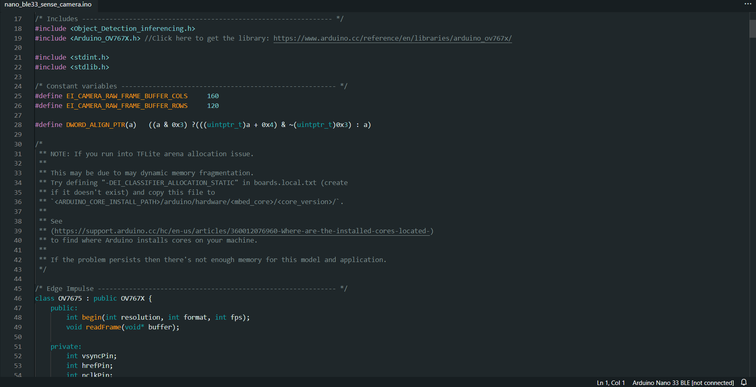

**Conclusion:** Practically implemented detect an object using Edge Computing. Understood about custom object detection.